3/9/2018

|  |
| --- |
|  |

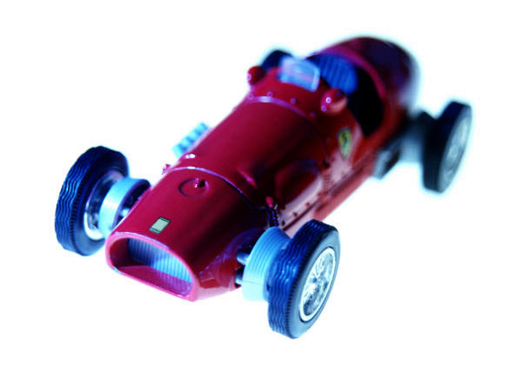

|  |  |
| --- | --- |
| Smart car project | Team 55 timeline plan |

***The TimeLine plan***

Our main aim is to finish work till stage two isa’allah by 9/3/2018 as follows:

* Week 1 &2&3 :Learning Arduino by all team members and divided into subteams where each team starts searching for all our needs in the project from his team’s perspective
* 24/3 : buying the body of the car
* 25/2 : make our first model of the car and test it by easy driving code
* 27/3 : check car functionality and prepare for the second coding test
* 3/3 : buying line tracker sensor
* 4/3 : attach line tracker sensor to the body and test it
* 9/3 : make sure the car is working well for all stages and solve any problems